**Help Document for “BlueDot Visualization Template: Infectious Disease Risk by Location”**

**Revision History**

|  |  |  |  |
| --- | --- | --- | --- |
| **Doc. Version** | **Date** | **Author** | **Description** |
| 1.0 | 2022-04-08 | Basam Ahmad | BlueDot infectious disease risk by location template help |
|  |  |  |  |
|  |  |  |  |

Table of Contents

Functionality 1

Location search report page 1

Data dictionary and methods report page 4

Access the template, and connect to BlueDot live data 5

Access the Infectious Disease Risk by Location template 5

Connect to BlueDot live data 5

Reach out to BlueDot for support 5

# Functionality

BlueDot’s visualization template for infectious disease risk by location enables users to pinpoint and understand infectious disease risks within locations of interest. With this template, you will clearly understand infectious disease risk and activity for specified locations, including total cases, deaths, incident rates, and disease characteristics (severity, transmissibility, mode of transmission, and preventability). In addition, gain greater context to key indicators with information regarding epidemic preparedness by location and relevant recent news. This template is part of a series of infectious disease intelligence visualization templates created by BlueDot.

This template consists of these pages below:

## Location Search Report Page

The “Location Search” is the landing page for filtering which consists of 3 steps:

1. Select timeframe for report
2. Search location (hit enter/return after your location) OR
3. Select location, right click on the location and “Drill through” the “Location Profile” or left-click “View”
   * Only one location can be selected at this time.

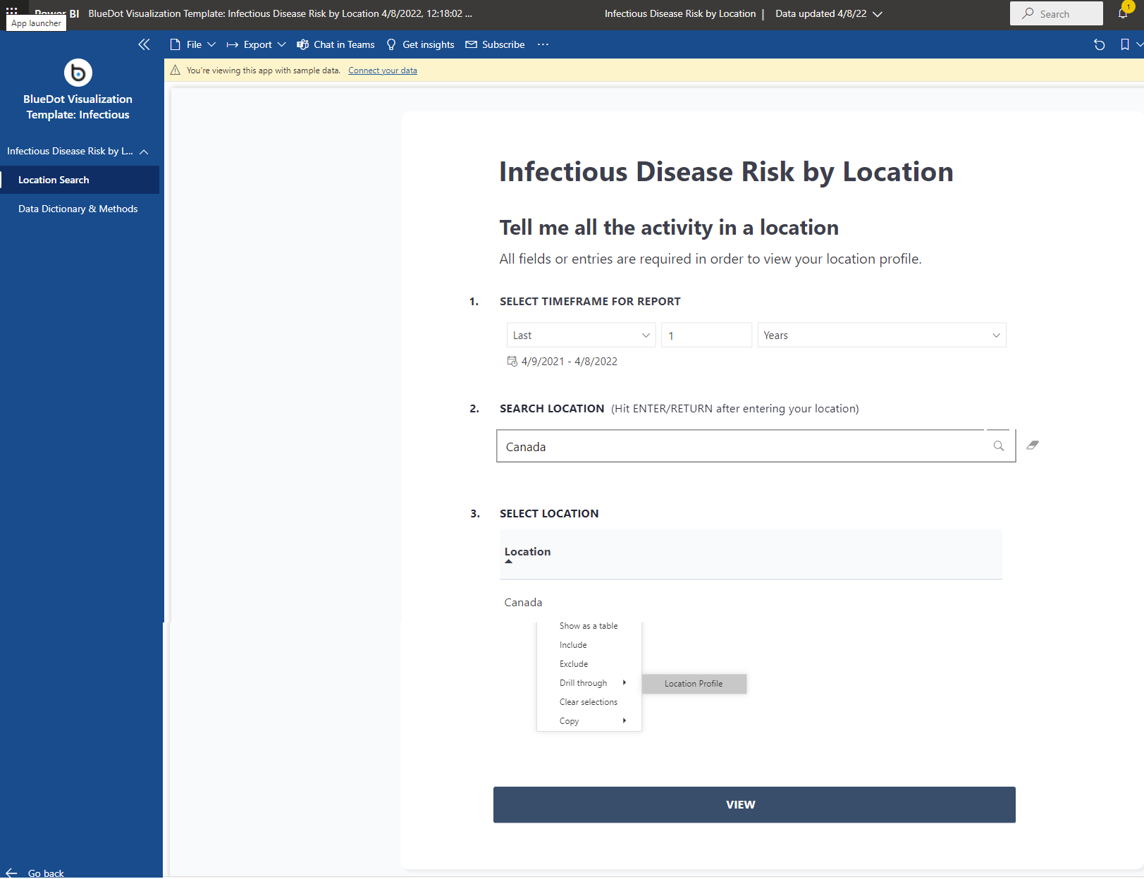

Screenshot 1: **Location Search**

## Location Profile Report Page

This page will show you the disease overview in the selected time frame (Diseases, Reported Case Incidences and Case Activity), the baseline epidemic preparation index (BEPI) developed by BlueDot, and the number of hospital beds per 10,000 in this location as listed by the World Health Organization (WHO).

Screenshot 2: **Location Profile**

1. Select a disease from the “Disease Overview” and click “View Disease Activity”. Additionally, diseases can be selected by right clicking the disease, and selecting “Drill Through”, and “Disease Activity”.

## Disease Activity Report Page

This section of the report gives you insights into the previously selected disease in the selected location. Here, Reported Case Incidences, Reported Deaths, Case and Death Activity History graph, and a subnational map of case incidences can be found. Furthermore, the Case and Death Activity History graph can be viewed in a table format by selecting the  icon in the right corner of the graph. The subnational map of case incidences can also be displayed as a table by toggling between the ”List” and ”Map” view.

Screenshot 3: **Disease Activity**

At the bottom of the Disease Activity report page, the Disease Profile page can be seen. The information displayed in this area changes based on the user's selection of disease in the Location Search and Location Profile pages.

## Data Dictionary and Methods Report Page

The Data Dictionary and Methods page can be found on the last tab of the template. Definitions for all terms used in the template will be listed here.

Screenshot 4: **Data Dictionary & Methods**

# Access the template, and connect to BlueDot live data

This section describes the process of installing the template from Microsoft AppSource, downloading, and connecting the template to BlueDot’s live data.

## Access the Infectious Disease Risk by Location template

1. Go to Microsoft PowerBI AppSource ([Business Apps – Microsoft AppSource](https://appsource.microsoft.com/en-US/marketplace/apps?product=power-bi)),
2. Search for the BlueDot “Infectious Disease Risk by Location” app,
3. Download the “Infectious Disease Risk by Location” template by clicking “Get it now”,
4. Fill in the form and accept the Microsoft agreement,
5. Click “Continue” and install the app to your workspace
6. The “Infectious Disease Risk by Location” will appear in your PowerBI workspace.

## Connect to BlueDot live data

The “BlueDot Visualization Template: Infectious Disease Risk by Location” comes with sample data by default. Please, reach out to BlueDot support for live data pricing and credentials.

# Reach out to BlueDot for support

Please, do not hesitate to reach out to BlueDot support at [support@bluedot.global](mailto:support@bluedot.global).